

INTERFACE DEFINITION DOCUMENT
SCRP0011_IDD_STOC
SCRP0011

Document Identification
Version History
Version history maintained by SharePoint

Approval
Name | Role | Date
Jaycee Wilken | Architect
Diane van der Merwe | GBBC - STOC System Owner
Sujeet Ghela | BI Project
Distribution
Name | Organisation | Date
Diane Van Der Merwe | STOC System Owner
BI Project team | Project team
Jan Hanekom | STOC RtB Manager

Table of Contents
1 Introduction 4
1.1 Executive Summary Scope 4
1.2 Purpose 4
1.3 Scope 4
1.4 Interface Parameters 4
1.4.1 Source impact analysis 4
1.4.2 Target impact analysis 4
2 Interface Process and Parameters 5
2.1 Business Rules 5
2.2 Interface Process 5
2.3 Source File Outlay 7
2.3.1 STOC Output and File Format 7
2.3.2 Data Required 7
2.4 Events and Event Descriptions 8
2.4.1 Exceptions - Err Exceptions 8
3 Interface Detailed Mappings 9
3.1 Source and Target Mapping Details 9
3.1.1 Source Feed Batch Header 9
3.1.2 Source File Detail 9
3.1.3 Source File Trailer 10
4 Glossary 12

Introduction

This document describes the details of the STOC feed to the BI solution. All the key components, which make the feed, have been put together as the Interface definition document.

Executive Summary Scope
The Business Intelligence project (BI), forms part of the Credit Automation initiative. Its Phase 1 objective is to implement a Risk portfolio viewer, utilizing Qlikview. To this extent, data from various source systems is required to populate the various reports and dashboards.
Interface requirements that are addressed in this document are specific to STOC; and which has been identified as important for the first phase of the project implementation. This includes Security and Facility information.
Qlikview is the selected BI technology for the Credit Automation project.

As part of the Credit Automation BI component, all feeds identified should originate from source systems.


Purpose
This document defines the file transfer methods and file formats used to provide data to the BI Risk Database. BI Risk Database is the data base which will feed queried data for the Qlikview reporting tool for the Credit Automation Risk function.

Scope
This interface covers the data flow from a STOC extract which feeds into the Risk Data Market Place (RMDP), a central repository for the Risk portfolio viewer.

Interface Parameters

Source impact analysis
Frequency: | Daily (Business Day)  - after End of Day run  - (00:00 -06:00)  - Prior to STOC Tasks run
Criticality: | High
Technology: | To be determined by STOC RtB
Destination: | BI Risk Database  Environments  - Dev: dcibmothds1v  - Uat: ucibmothds1v  - Prd: TBC  Location  - /cygdrive/r/SourceFeeds/Stoc  Users  - Dev: uat_credit  - Uat: uat_credit  - Prd: cib_credit

Target impact analysis
Expected time of feed delivery | Dependant on Source frequency
Last time of feed delivery | 06:00
Business impact of late delivery | Collateral information viewed will be outdated – data available as per previous successful business day
Business impact of no delivery | Collateral information viewed will be outdated – data available as per previous successful business day
Priority of the feed | Medium

Interface Process and Parameters
This section describes the interface process, parameters required and the impact this has on business.

Business Rules
- Only ACTIVE records per customer should be included in the feed. ACTIVE status is determined as follow:
  - Security Records - All security records per customer where the [SECURITY STATUS] = “ACTIVE”.
  - Facility Records - All facility documents =where the [DOCUMENT STATUS] = “ACTIVE”.
- Only the latest feed received from STOC should be imported into Qlikview.
- Data reconciliation is not part of the phase 1 scope.

The diagram below depicts the relationship between Security and Facility information in STOC.
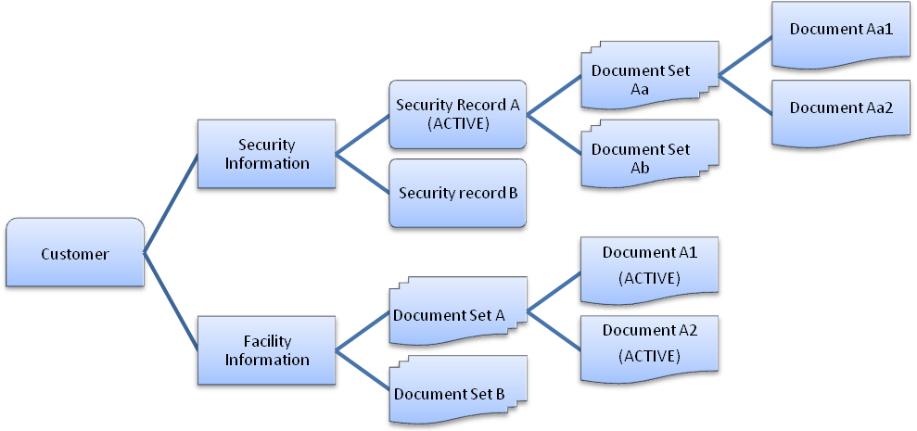

Interface Process
Presents a high-level overview of the activities involved in this interface. The remainder of the sub-section provides a detailed description of each activity.

- STOC produces an extract file.
- The feed is imported into the RDMP.
- Data is accessible by Qlikview for reporting purposes.

The diagram below depicts the process of making GBBC data available for BI (RDMP):

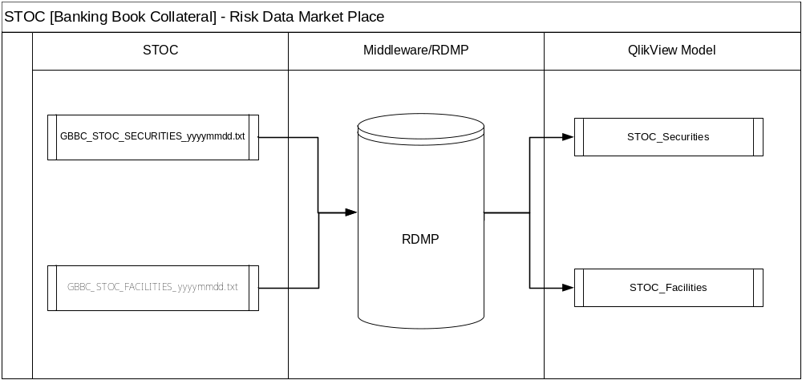

Source File Outlay

STOC Output and File Format
Filenames: [GBBC_STOC_SECURITIES_{YYYYMMDD}.txt]
[GBBC_STOC_FACILITIES_{YYYYMMDD}.txt]
- {YYYYMMDD} = Business Date
Delimiter: Pipe delimited
File Type: txt

The following table gives a short description of each field.

Data Required
Data is required for Security and Facility records.

Security Information Required
The following Security information is required

No. | Source Field Name | Description
 | Customer_Number | This describes the CIF number that uniquely identifies the customer.
 | NAME | This describes the customer’s name.
 | Security_ID | This describes the number that uniquely identifies a security.
 | Asset Type | Asset Type represents the following contract/ security types: Assurance, Call Option, Cash and Cash Equivalents (Cash, Customer Foreign Currency, Deposit other Financial Institutions, Standard Bank Investment, 3rd Party), Cessions (General, Other), Equities (Listed, Single Stock, Unit Trusts, Unlisted), Fixed/Immoveable property, Guarantee, Letter of Support, Moveable Assets (General, Special), Non- Exchange Traded Commodities, Pledges Other, Promissory Notes Other Held etc.
 | Unlimited | Indicates that the security is not restricted to an amount.
 | Restricted_Currency | The currency of the restricted amount attribute.
 | Restricted_Amount | Amount the security value is restricted to.
 | Percentage_Collateralised | A restriction to a percentage of the total amount outstanding by the Collateralised Counterparty.
 | Valuation_Date | This is a date field of when the security is valued.
 | Market_Value | The most recently available gross/face/market value of the collateral (not the expected recovery value) prior to applying any haircuts. This is the value of the security as determined in the open market.
 | Covenant_Value | As prescribed by the terms and conditions within the agreement between the bank and the customer. Could potentially be used for covenant ratio monitoring.
 | Recovery_Value | The monetary value expected to be raised from the realisation of the security
 | Value_Currency | The currency in which the security is denominated.
 | Valuation_Frequency | This field indicates how often the security is to be re-valued.
 | Expiry_Date | The date on which the enforceability of the security lapses
 | Transaction Specific | The security relates to a specific transaction rather than all facilities availed to the customer
 | Restricted_Transactions | Specifies which transaction the security is restricted to
 | Product Specific | The security relates to a specific product rather than all facilities availed to the customer
 | Restricted_Products | Specifies which product the security is restricted to
 | Basel_Eligible | Indication of whether the security is Basel eligible or not i.e. Yes/ No
 | Basel_Ineligible_Reason | This is the description of why the security is not Basel eligible
 | User_Disqualified_Reason | Reason for manual disqualification of security
 | Party_To_Document | CIF number or other unique identifier of other parties if there are other parties to the security
 | Party_Role | Description of the other parties involvement with the security
 | PARTY_NAME | Name of the party linked to the security
 | Party_Registration_Number | Companies Act registration number of party if a company. ID number if it is an individual.
 | Recovery_Percentage | This description is specific to Book Debts. The recovery percentage is derived from the recovery value and covenant value.

Facility Information Required
The following Security information is required

No. | Source Field Name | Description
 | Customer_Number | This describes the CIF number that uniquely identifies the customer.
 | Location | Identifies the booking entity (host) within the Standard Bank Group derived from Adaptiv
 | Date_of_Document_Load | Date on which extract was provided by STOC
 | Customer_Number | Customer CIF number
 | Document_Set_Name | Grouping of similar document types
 | Document_Name | Name of specific document type within grouping
 | Document_Id | Unique ID allocated to individual documents
 | Legal_Opinion_Held | 0 = No and 1 = Yes. We are only as good as the documentation furnished to us so either we hold a the Legal Opinion or we don't. Typically we do not rigorously enforce legal opinions on Legal documentation only on Security items, where we need to refresh these annually if documents are to remain valid for capital purposes.
 | Date_of_Signature | Date that document was signed by signatories
 | Standard | 0 = Non-standard and 1 = standard which is based on whether or not the bank has a standard template for the document and NO amendments have been agreed to. We migrated information from another system and in some cases there was no data to migrate and we could not write a consistent business rule to deals with all the blanks. These fields will be populated over time as and when we next edit these records.
 | Copy | This relates to whether or not we hold an original document. In some cases there was no data to migrate and we could not write a consistent business rule to deals with all the blanks. These fields will be populated over time as and when we next edit these records.
 | Grace_Period_Days | If the documentation requires that the collateral provider be given 'x' number of days grace before we can enforce our documents we record this here.
 | Irregular | Potentially there can be one of 3 values populated here: 1 = No, 2 = Yes - Accepted and 3 = Yes - Material.
 | Party_To_Document | CIF number or other unique identifier of other parties if there are other parties to the document
 | Party_Role | Description of the other parties involvement with the document
 | Party_Name | Name of the party linked to the document
 | Party Registration Number | Companies Act registration number of party if a company. ID number if it is an individual.
 | Comments | Additional information relevant to the document

Events and Event Descriptions

Exceptions - Err Exceptions
Utilise existing error logs.

Interface Detailed Mappings

Source and Target Mapping Details

Source Feed Batch Header

Field No | Template  Attribute Name | Data  Content Notes | Attribute  Description
1 | Header | “Header”
2 | Business Date | yyyyMMdd | This is the business date for which the extract has been produced

Source File Detail

Security Information
Field No. | Target Field | Source Field | Type (Length) | Required  (M / O) | Comment
 | Customer_Number | CIF | Text (20) | M
 | NAME | Name | Text | O
 | Security_ID | Security ID | Text | O
 | Asset Type | Asset Type | Text | O
 | Unlimited | Unlimited | VARCHAR2 (10) | O
 | Restricted_Currency | Restricted Currency | VARCHAR2 (3) | O
 | Restricted_Amount | Restricted Amount | Number (22) | O
 | Percentage_Collateralised | Percentage Collateralised | Number | O
 | Valuation_Date | Valuation Date | VARCHAR2 (8) | O
 | Market_Value | Market Value | Number (22) | O
 | Covenant_Value | Covenant Value | Number (22) | O
 | Recovery_Value | Recovery Value | Number (22) | O
 | Value_Currency | Value Currency | VARCHAR2 (8) | O
 | Valuation_Frequency | Valuation Frequency | Text | O
 | Expiry_Date | Expiry Date | VARCHAR2 (8) Text | O
 | Transaction Specific | Transaction Specific |  | O
 | Restricted_Transactions | Restricted Transactions | VARCHAR2 (2048) | O
 | Product Specific | Product Specific | Text | O
 | Restricted_Products | Restricted Products | Text | O
 | Basel_Eligible | Basel Eligible | VARCHAR2 (8) | O
 | Basel_Ineligible_Reason | Basel Ineligible Reason | VARCHAR2 (8) | O
 | User_Disqualified_Reason | User Disqualified Reason | Text | O
 | Party_To_Document | Party To Document | Text | O
 | Party_Role | Party Role | Text | O
 | PARTY_NAME | PARTY_NAME |  | O
 | Party_Registration_Number | Party Registration Number | Text | O
 | Recovery_Percentage | Recovery Percentage | Number (22) | O

Facility Information
Field No. | Target Field | Source Field | Type (Length) | Required  (M / O) | Comment
 | Customer_Number | CIF | Text(20) | M | Name of customer
 | Location | Location | Text | O | Date on which extract was provided by STOC
 | Date_of_Document_Load | Date_of_Document_Load | Text | O | Customer CIF number
 | Customer Name | Customer Name | Text |  | Name of SBG booking entity
 | Document_Set_Name | Document_Set_Name | Text | O | Grouping of similar document types
 | Document_Name | Document_Name | Text | O | Name of specific document type within grouping
 | Document_Id | Document_Id | Numeric | O | Unique ID allocated to individual documents
 | Legal_Opinion_Held | Legal_Opinion_Held | Number | O | 0 = No and 1 = Yes. We are only as good as the documentation furnished to us so either we hold a the Legal Opinion or we don't. Typically we do not rigorously enforce legal opinions on Legal documentation only on Security items, where we need to refresh these annually if documents are to remain valid for capital purposes.
 | Date_of_Signature | Date_of_Signature | VarChar2 | O | Date that document was signed by signatories
 | Standard | Standard | Number | O | 0 = Non-standard and 1 = standard which is based on whether or not the bank has a standard template for the document and NO amendments have been agreed to. We migrated information from another system and in some cases there was no data to migrate and we could not write a consistent business rule to deals with all the blanks. These fields will be populated over time as and when we next edit these records.
 | Copy | Copy | Irregular | O | This relates to whether or not we hold an original document. In some cases there was no data to migrate and we could not write a consistent business rule to deals with all the blanks. These fields will be populated over time as and when we next edit these records.
 | Grace_Period_Days | Grace_Period_Days | Numeric | O | If the documentation requires that the collateral provider be given 'x' number of days grace before we can enforce our documents we record this here.
 | Irregular | Irregular | Irregular | O | Potentially there can be one of 3 values populated here: 1 = No, 2 = Yes - Accepted and 3 = Yes - Material.
 | Party_To_Document | Party_To_Document | Text | O | CIF number or other unique identifier of other parties if there are other parties to the document
 | Party_Role | Party_Role | Text | O | Description of other parties involvement with the document
 | Party_Name | Party_Name | Text | O | Name of the party linked to the document
 | Party Registration Number | Party Registration Number | Text | O | Companies Act registration number of party if a company. ID number if it is an individual.
 | Comments | Comments | Text | O | Additional information relevant to the document

Source File Trailer
Field No | Template  Attribute Name | Data  Format | Data  Content Notes | Attribute  Description
1 | Trailer |  | “Trailer” | Indicates the start of the Trailer section
2 | Record Count | Number |  | Count of all the records contained in the file

Glossary

Term | Description
RDMP | Risk Data Market Place
STOC | Systematic Tracking of Collateral
BI | Business Intelligence

